Rover: Working More Efficiently on The Go

Declan Ruiz and Zach Shellhorn

Brownsburg High School
Engineering Design and Development
April 17-26, 2019

Rover: Working More Efficiently on The Go
Declan Ruiz and Zach Shellhorn
Engineering Design & Development
Mrs. Floyd
April 17-26, 2019

Abstract
Our project solves the problem of working on the go. So many people are working remotely, rather than in offices, the only issue is they aren’t working efficiently enough. Cynthia Ruiz is a speech language pathologist and travels from school to school helping students with their speaking, reading, and swallowing issues. Because she has to go from school to school, she must carry all her school supplies. Our goal was to solve that issue, so Cynthia Ruiz could work remotely with ease. We then designed our prototype after extensive research to build our re-designed briefcase. Our design includes a durable handle, sturdy latches and hinges, and an efficient computer stand. Our next steps would be to take our model to companies to see if they would be willing to mass produce it. As of now people love our prototype and can’t wait for it to in production one day.

Table of Contents
Abstract ii
Lists of Tables and Figures vi 1.0 Summary 7
2.0 Introduction 19
3.0 Methods, Assumptions, and Procedures 25
4.0 Results & Discussion 26
5.0 Conclusion 85
6.0 Recommendations 87
7.0 References 90
Appendices 93

List of Figures
Figure 1. Flip-Out Table Backpack 19
Figure 2. Table Top Suitcase 20 Figure 3. 30in Rolling Travel Workstation 21
Figure 4. Briefcase Design 22
Figure 5. Table Suitcase 22
Figure 6. Decision Matrix 24

List of Tables
Table 1. Survey Results & Analysis 8
Table 2. Testing Data for Latch Test 24
Table 3. Testing Data for Hinge Test 52 Table 4. Testing Data for Handle Test 80
Table 5. Expense Report 81
Table 6. Test Criteria xlsx 88.

1.0 Summary
1.1 The Problem:

Upon use and inspection of a briefcase we found that they aren’t efficient enough. This is familiar with all other types of business materials used currently. It was discovered from our survey that people that worked as teachers, salesmen/women, or were a student believe they could be more productive in their work. We also found that more people are working remotely and on the go. Office spaces costs a lot, as little as $1.74/sq. ft. in Atlanta to as much as $6.16/sq. ft. in Los Angeles. This is why ¾ of the population will be working remotely by 2020. Since 40% of people check their email at least 5 times a day outside of the house or office and with office spaces being so expensive, business men/women, teachers, entrepreneurs, salesman, etc. are looking for efficient ways to “work on the go.”

1.2 Method of Investigation:

We mostly took other people’s words from surveys and did numerous amounts of research online. We researched costs of offices, briefcases, portable desks, etc. We also looked at why people said it was a problem to them. We also had to find tons of different patents to make sure there was not already a solution to our problem. If there was then we would either have to find a new problem or find a new solution.
We started out by brainstorming ideas to solve the issue of working remotely, while being efficient with your time, managing your productivity, and lowering the costs. We found numerous articles, websites, speeches, and data proving that this is an issue that the daily human faces. And with the help of these resources we were able to come up with a basis for our problem statement. After we got our problem statement finalized and had found numerous factual pieces
of evidence to back our idea, we set out to find information from the daily consumers through a survey. This was extremely beneficial to us because it let us know exactly what the consumer would purchase if we were to ever build an actual product.
After about five months of research we finally got to design, develop, and test our model. We only constructed the one model so we had to do tests that wouldn’t destroy the prototype entirely. We did tests to the latches, the hinges, and the handle. All of these tests however were inconclusive because we only had time to test them for 1,000 repetitions each.

Table 1.
Survey Results & Analysis:
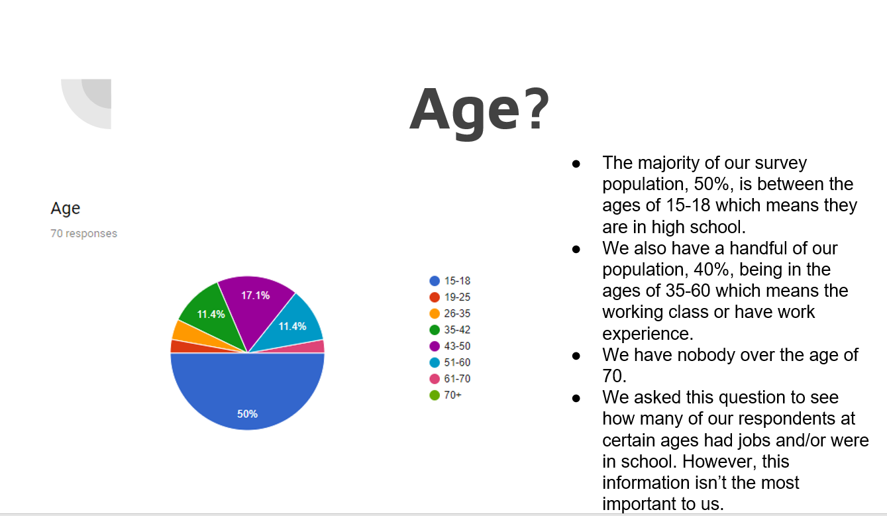
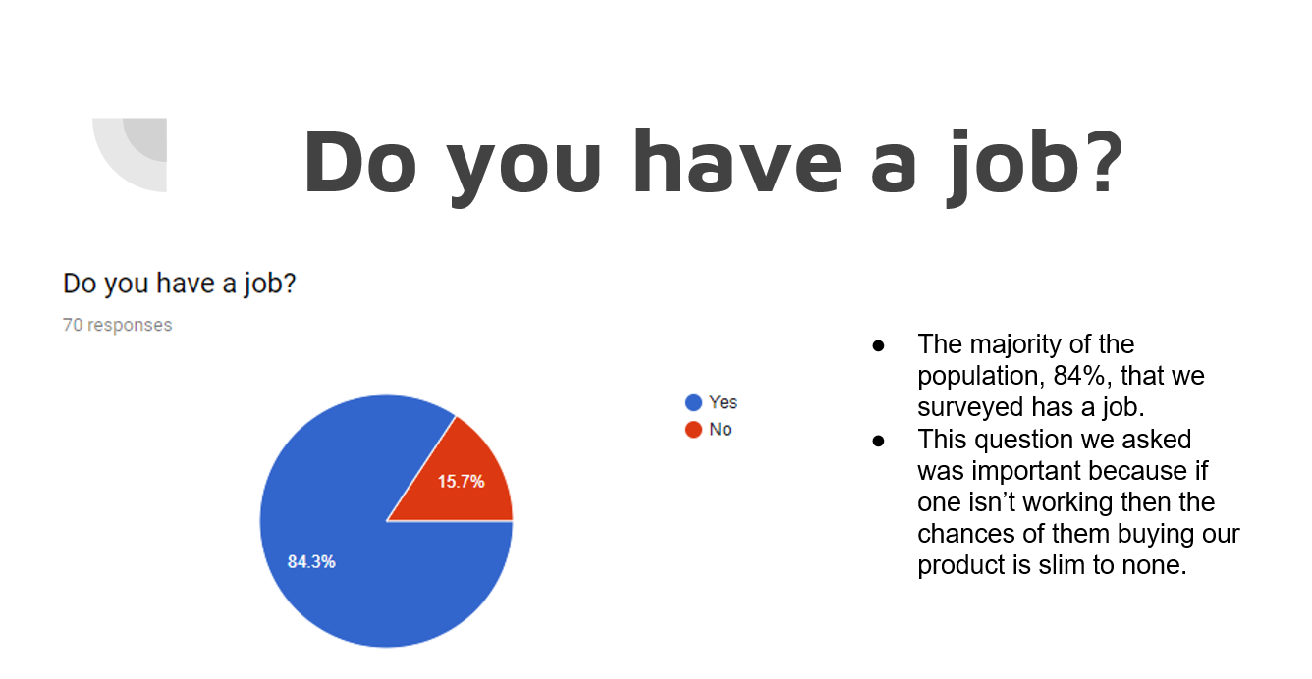

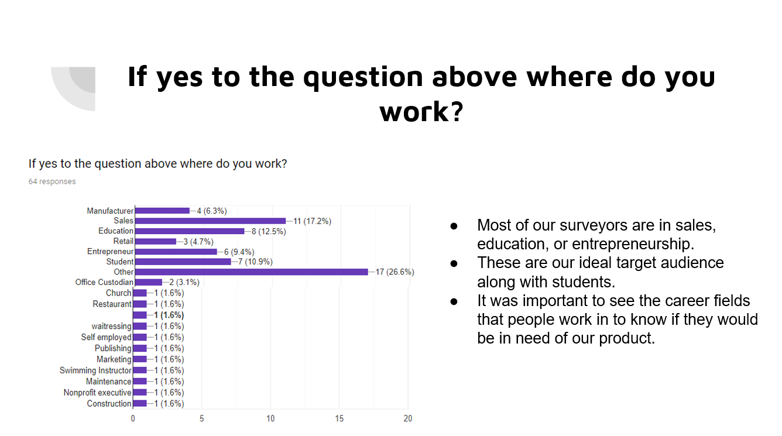
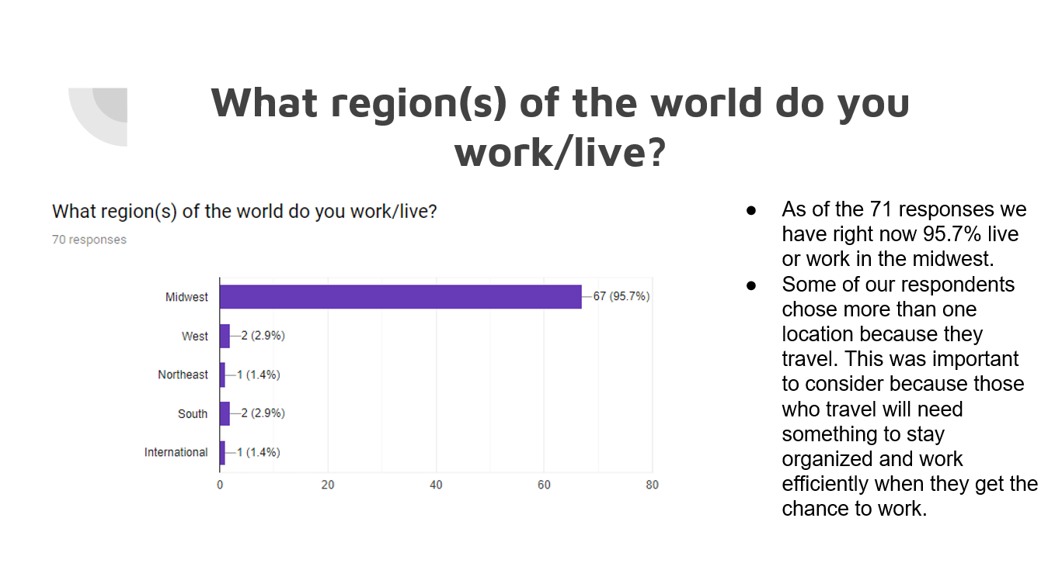
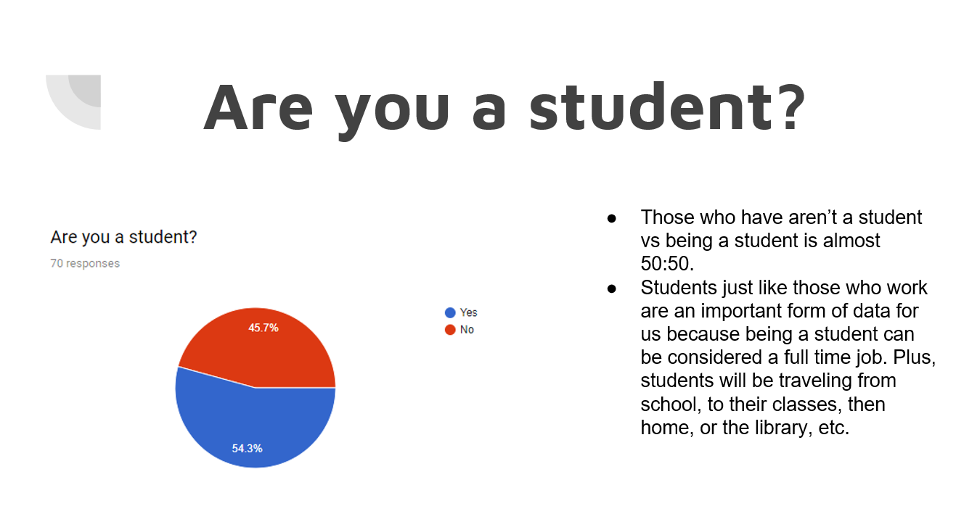
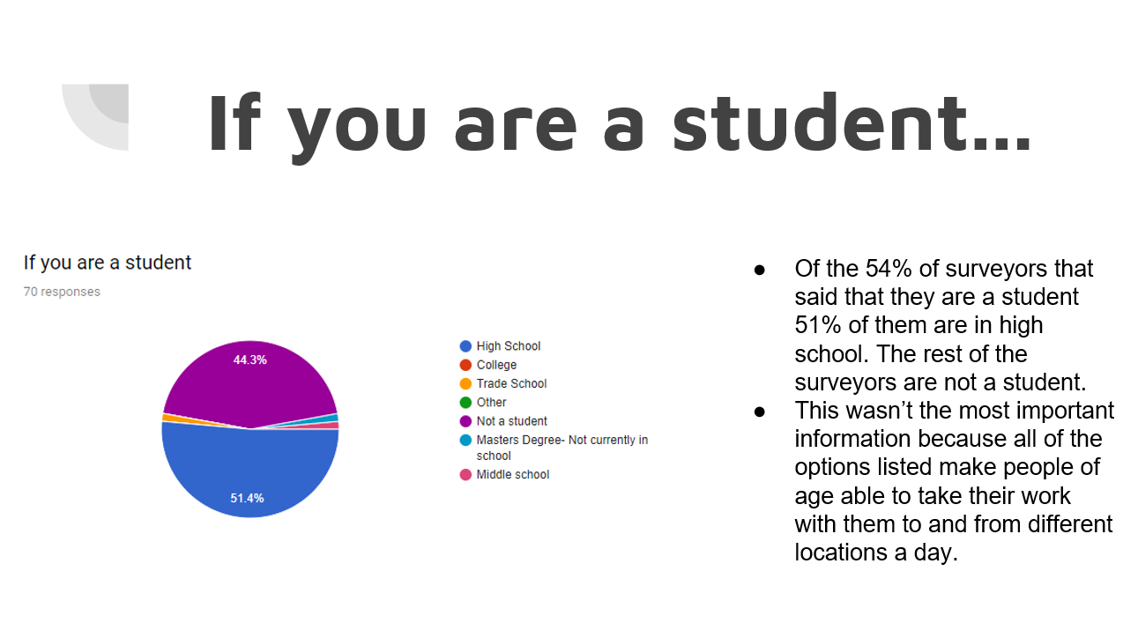
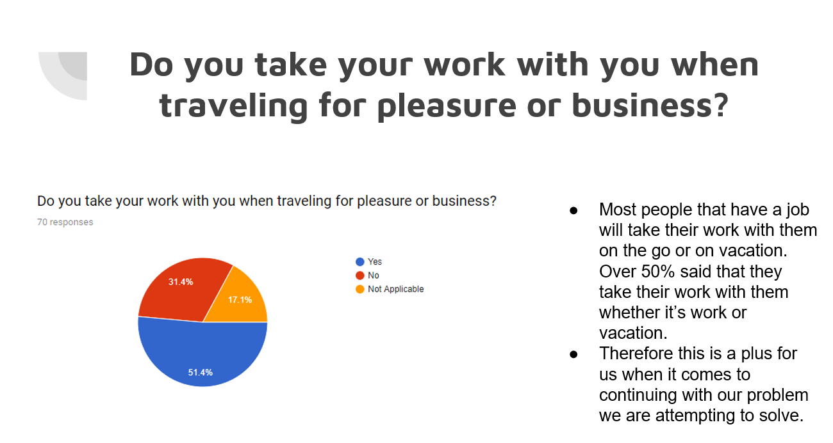
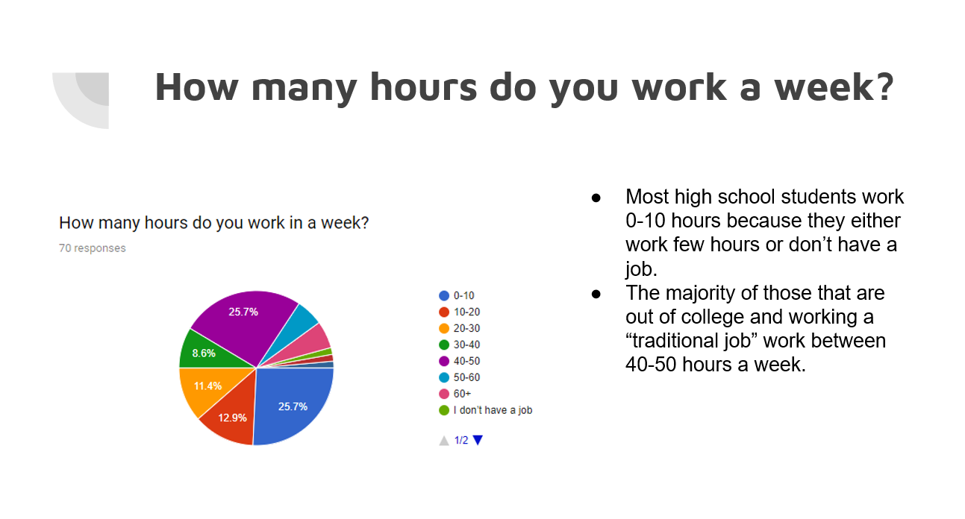
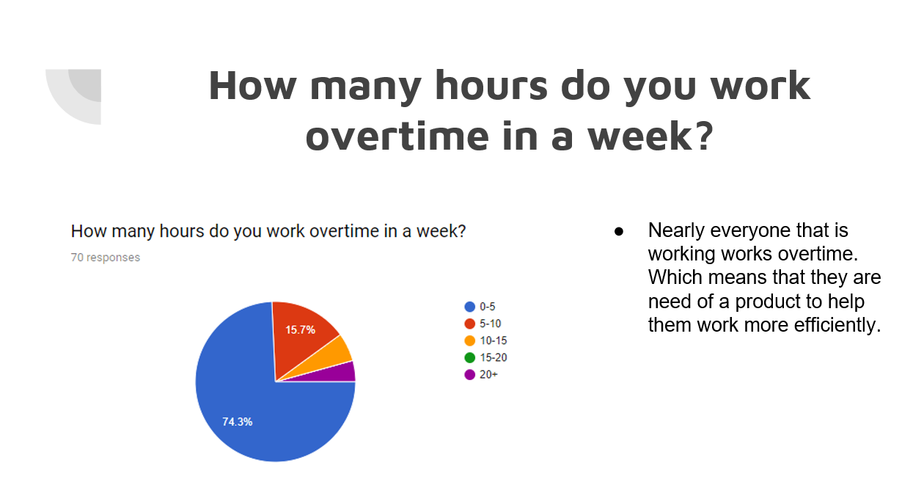
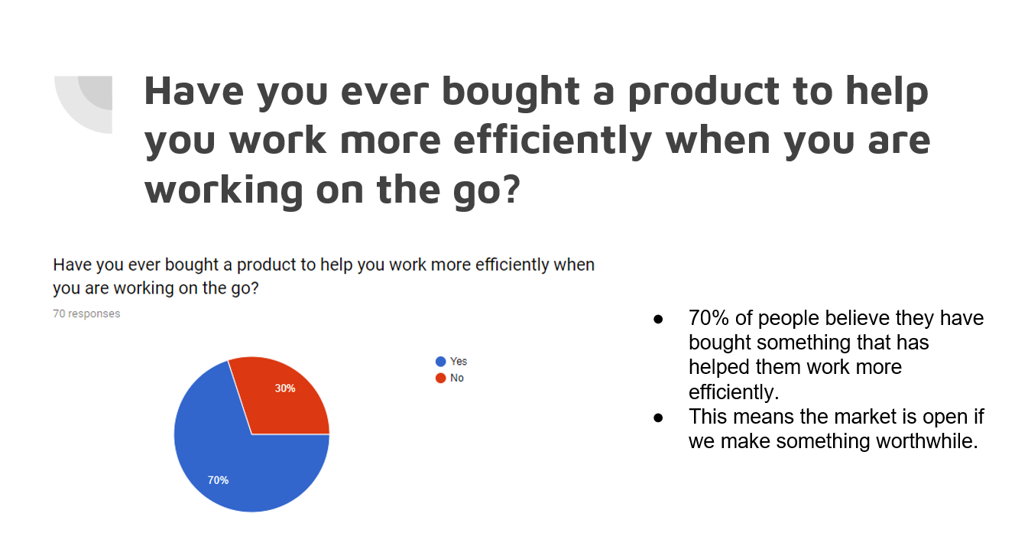
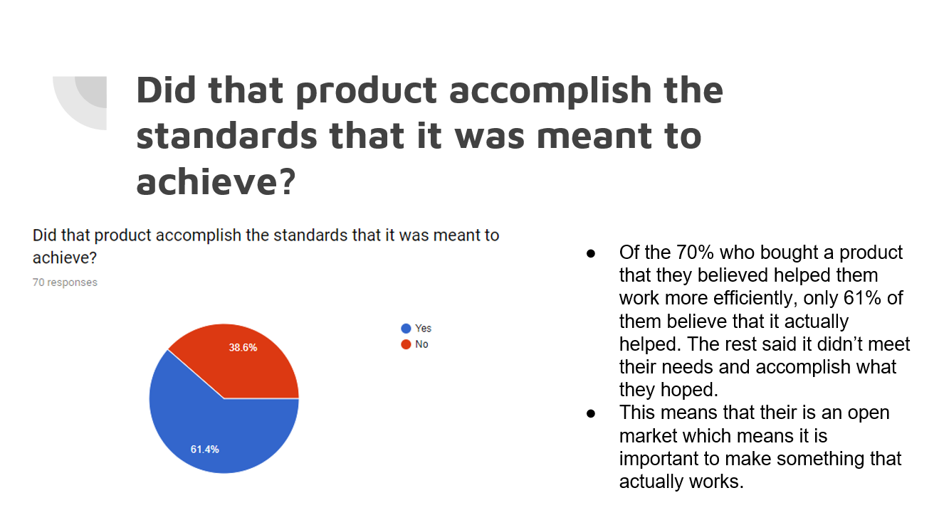
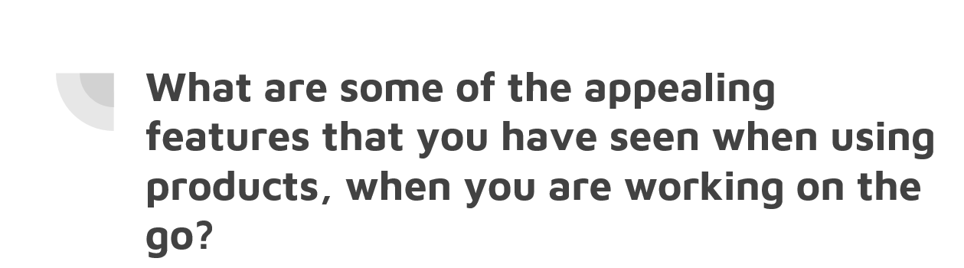
●Charging station/hot spot/ internet/external drives
●Work top for laptop/tablets
●small/portable
●Simple
●Back pack
●Durable
●Unlimited space on phone
●Reliability
●Holds a laptop
●Quality seemed higher the more expensive the item was
●Light weight
●Cheap
●Easy to use
●Efficient
●To help show other how to improve
●Portability
●Durable wheels
●Extra pockets / lots of storage space

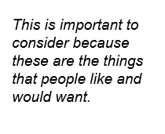
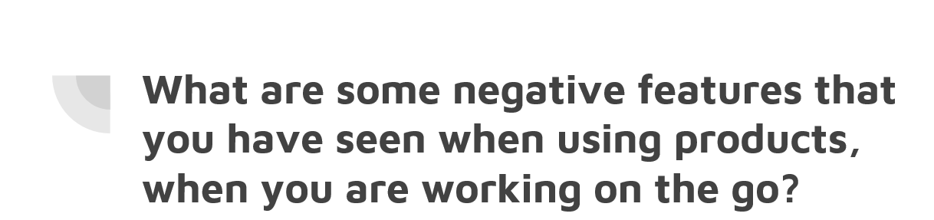
●Bulky
●Cheap
●Small pockets
●Breaks easy/Fragile
●Poor quality
●No portable charger
●No work surfaces
●Too heavy
●Too big
●Not big enough
●Not portable
●Too expensive
●Inefficient
●Not easy to use
●Not enough space to store stuff
●Annoying to carry around
●Not comfortable
●Not reliable
●Not secure
●Batteries don’t last long enough
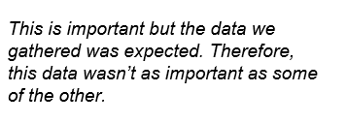
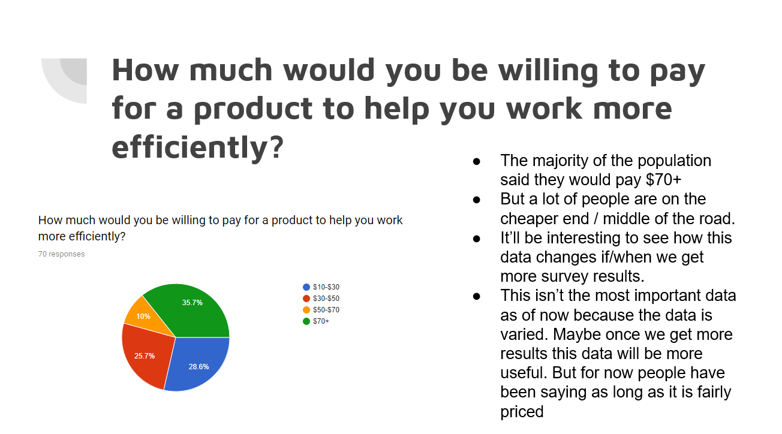
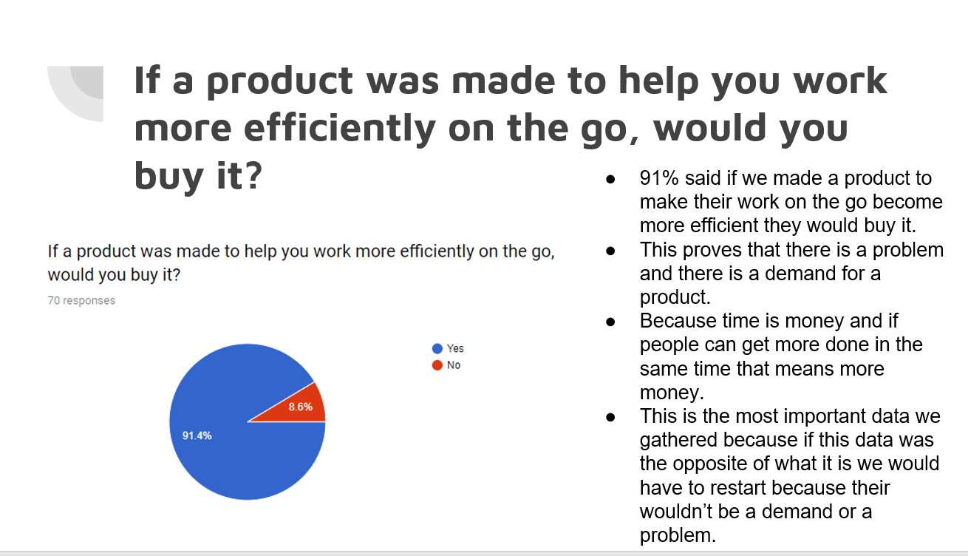
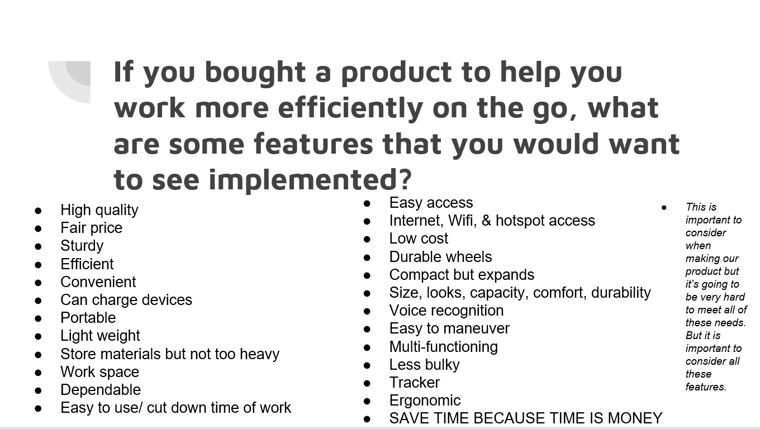

1.3 Conclusion:

Throughout the duration of this project and process we had many successful moments and a few failures, or more like setbacks. We were good friends before this project started therefore, it made it easy to work with each other. We communicated very well on everything and often compromised on all assignments. We both realize how important it is to get good grades to make it in our next steps as a college student. With that being said, we both understand that we need to have good work ethic to get all our work done on time and produced with maximum effort. We also worked well on the physical construction of our model/prototype.
On the flip side we aren’t the greatest at public speaking in front of others. We aren’t bad but we could definitely be more confident, well spoken, and more prepared when it comes to presenting. We also like to have fun way too much and sometimes gets us in trouble. But our reason for this is because it is hard to focus for two class periods a day, every day. Another actual failure we faced was during our testing. We were planning on testing how much the handle could hold by adding weight to the briefcase and seeing how much strain could be put on the handle before it broke. Upon set up of the test we realized we weren’t properly equipped with the right tools/machines to test the handle. We would need something to hold the briefcase while we added weight because it got way too heavy for us to hold.

1.4 Recommendations:

If we were to ever fix any part of this project we would start with the design. Our design was based on research and survey results that we got from the public, rather than our own views on how to solve the issue. Yes, the project is based on research, but if we were to make our design for real, we would make something that is actually beneficial. We would start with something more portable, light weight, and makes working more efficient.
If we were to fix anything on our pre-existing prototype, we would make the primary material (wood) a thinner cut, so it is not so bulky or heavy. We would have added the flaps that we drew up previously. However, we ordered a computer stand that would go in the bottom of our briefcase and when we got it the stand was thicker than expected. This made the laptop sitting on top to sit higher than expected. Which ultimately made no room for the flaps that were drawn up in our sketches and inventor renderings. To go along with this, we would make the bottom half deeper and the top half shallower so that the computer stand, and computer would be able to sit underneath the flaps. This would make the overall width of the briefcase the same, but the individual dimensions would be different. These are all the modifications that we have been presented from our peers and from our own investigations.

2.0 Introduction
2.1 Subject:

While working on the go we found it is very challenging to work efficiently. Our goal was to find a more efficient way for consumers to work on the go. Throughout the research that we did over many weeks we found many popular products that did not meet the needs of their clients and we looked for new ways to help them. After conducting a survey, we found exactly what consumers would want in a product to work on the go. While drawing out many prototypes we were able to decide on one prototype through a decision matrix that best fit the most of our consumer’s needs. This final prototype more efficiently helps people who are working on the go.

Figure 1.
Flip-Out Table Backpack
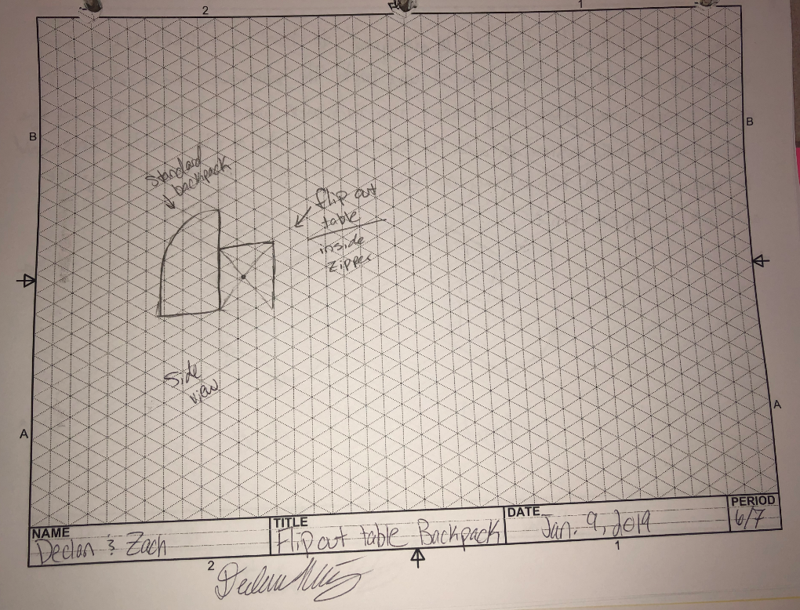
Figure 2.
Table Top Suitcase
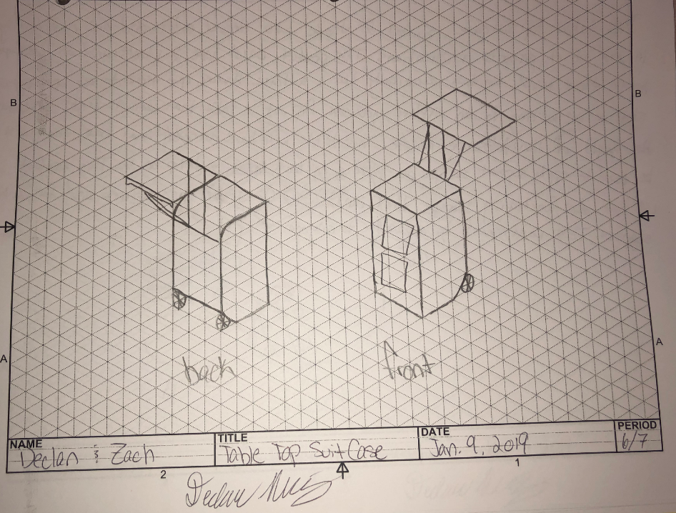

Figure 3.
30 in Rolling Travel Workstation
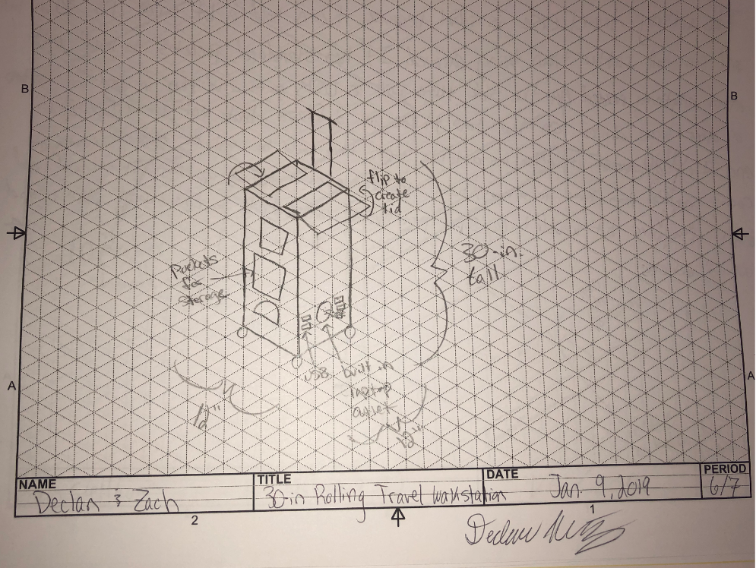

Figure 4.
Briefcase Design
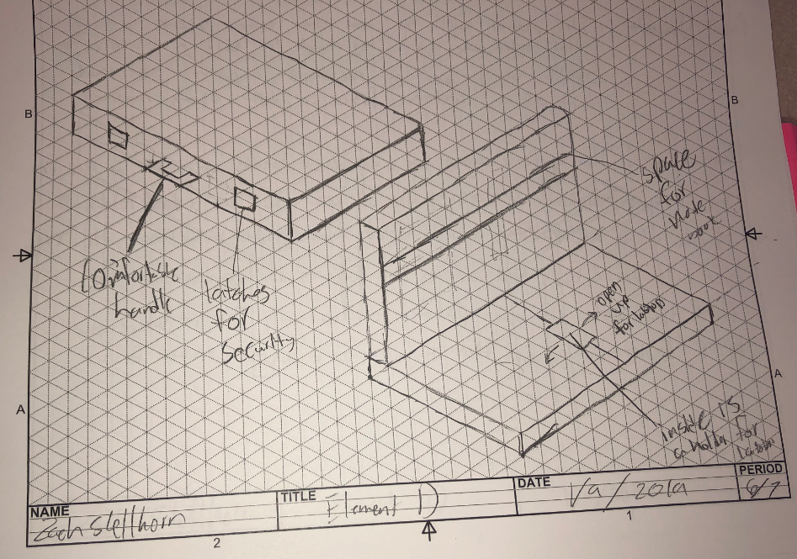

Figure 5.
Table Suitcase
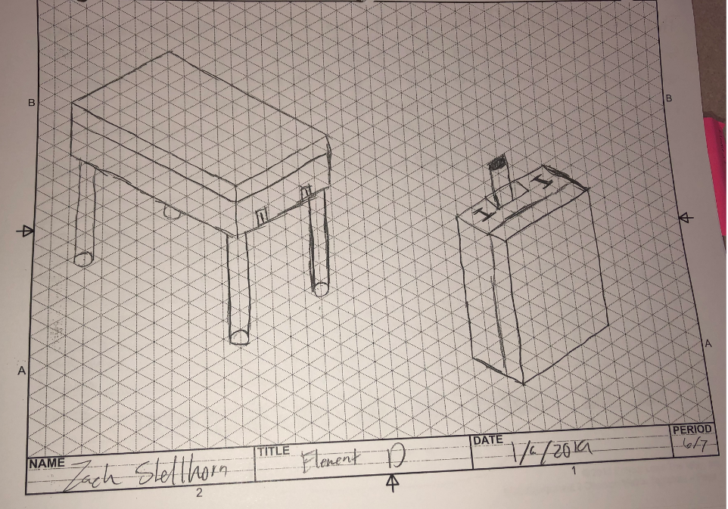
2.2 Purpose:

Upon hours of research that was put into finding answers about working on the go we realized we would need to find a solution because there hasn’t been an effective one made yet. Cynthia Ruiz is a speech language pathologist and she travels from one elementary school to another 5+ times a day and then comes home every day. She is required to carry all her school supplies with her from school to school because she does not have her own classroom to leave her materials in. So it was clear that this was a personal problem to my family and made a great project idea for engineering design and development class. After, we started doing our research we had to switch up our approach a little because our survey said they wanted different criteria than we originally had in mind. We originally had a rolling briefcase design in mind because it could hold more material and would not have to be carried because it rolls. This was shut down because it gets too heavy and would be hard for some to get it in and out of their vehicles. We also thought of a backpack style carrying device, but a lot of students complain of back problems, so we scratched that idea as well. This is the quick and simple version of where our briefcase design came from.

Figure 6.
Decision Matrix
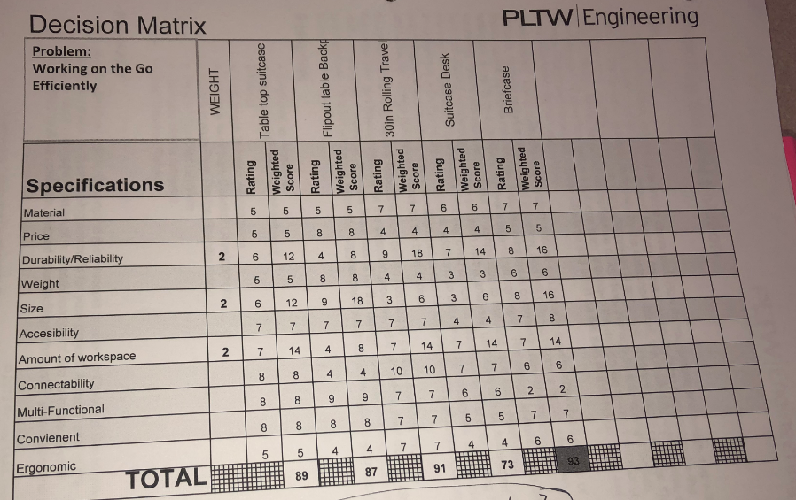

2.3 Scope:

This technical report provides information on the ideas behind the development of our project. This will show how we reached our final project from the beginning of the year. We started out with research behind the idea of working more efficiently on the go, from there we put a survey to narrow down to our targeted audience. When we started to design the actual product, we were able to look back at all of that plus the patent research we had done to find five or six strong ideas. We put those ideas through a decision matrix to find our strongest idea for our project. When we found the idea, we bought the materials and then built the briefcase. This report will go into depth about the most important parts of this project and how we accomplished different parts.
3.0 Methods, Assumptions, & Procedures
3.1 Methods:

I discovered this problem because Cyndi Ruiz, the mother of Declan Ruiz, travels from school to school as a Speech Language Pathologist. With this being said Cyndi has to take all her school supplies with her because she does not have one classroom. She has used a dozen or so traveling cases to carry her school supplies, but they all break or cannot hold all the required materials. Also, Anthony Ruiz and Aaron Shellhorn, the fathers of Declan Ruiz & Zach Shellhorn, are in sales. This means they travel a lot for work and have to carry different work materials with them. They informed us that they would like something to help them be more productive while also being easy to use and keep them organized.
Some of the tools that were used in the making of our prototype were a jigsaw, table saw, drill, orbit sander, tape measure, speed square, and a Dremel. We used screws to attach all wood components together. We measured everything using a tape measure and measured everything in inches.
There is not much that cannot be easily recreated; however people might wonder how the computer stand is attached to the bottom of the briefcase. We made the computer stand detachable so the consumer can use the computer stand upon arrival of their destination.
We gained a better understanding of the problem by researching the topic over a period of about 4-5 months. Then we spent a couple of weeks gathering survey results, which was the most useful because it gave us insight on what the consumer really wanted in a product. It also described what they hated about old concepts dealing with working on the go, and how they would like us to fix that.

4.0 Results & Discussion
4.1 Results:

From our extensive research that there are many different avenues to approach this problem. However, there were better options than others. When we were doing research, we found really neat ways to solve this problem of working on the go. However, when we cross referenced these ideas with our feedback from our surveys, they didn’t correlate. So, once we finished with all our research we had to go back to thinking of designs and ideas. Therefore, we learned that we should wait until we have all of our research done before we start conceiving ideas. This is one thing we learned from our problem during research.
One thing that we learned quickly in building our prototype was that the wood we used was really thick. We did this originally so it would be easier to construct, but after we completed the briefcase, we realized how heavy the thick wood made the briefcase. Then when we placed the computer stand and laptop inside the briefcase, it made the briefcase uncomfortably heavy. If there is one thing that we learned from constructing our prototype and analyzing it post construction, it would be the weight of the briefcase. This was mainly due to the lack of supplies readily available to use and the money constraints we were faced with.
Another thing we realized post construction was that in order for the laptop to sit on the computer stand inside the briefcase without sliding, the bottom half of the briefcase needs to be much thicker. Through carrying the briefcase to see how things moved around we were able to figure out that the laptop was sliding around. This is due to the top and bottom half of the briefcase being the same thickness. This made the computer stand sit flush with the bottom half of the briefcase, making the laptop sit just above that. Therefore, upon moving it from laying horizontally to vertically the laptop slides around. This is a major problem because people would be buying our prototype to protect their belongings rather than damage them.

4.2 Discussion:

When we started testing, we predicted that, from the 1,000-repetition test minimum that we had to meet, we would not find any results. Sure, enough throughout the duration of the testing we didn’t get any conclusive results. The thing we learned from this part of our research was testing more so we would have conclusive results. Like stated above, unfortunately after 1,000 repetitions of opening and closing the hinges and latches we found that they did not break, deform, or hinder in performance. The results can conclude that our prototype is sturdy and won’t lack in performance, but at the same time we won’t know exactly the failing point because we didn’t have enough time to test that. In the figures below you will be able to personally check every single trial of each test procedure. As you can see, neither the hinges nor the latches broke in the 1,000 repetitions that it was tested. Upon opening and closing the latches and hinges it was obvious that it would take thousands upon thousands of trials for each test before any conclusive results would be reported. It was obvious how sturdy the latches and hinges were. This was noticeable in a good way and added to the overall sturdiness and rigidness of our briefcase.

Table 2.
Testing Data for Latch Test
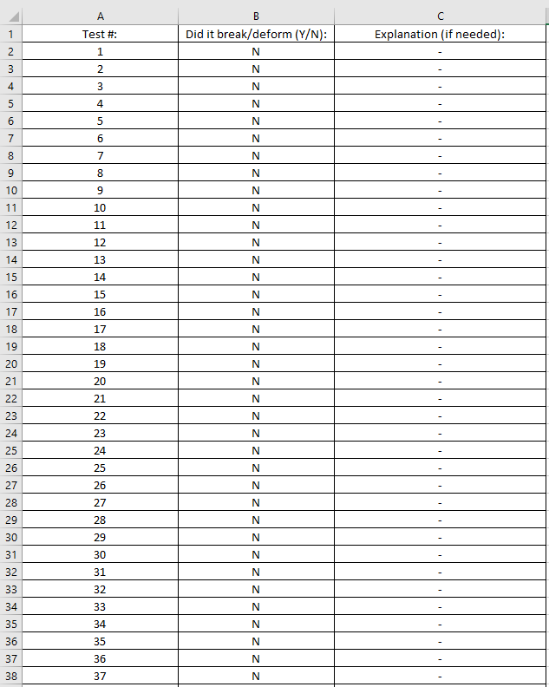
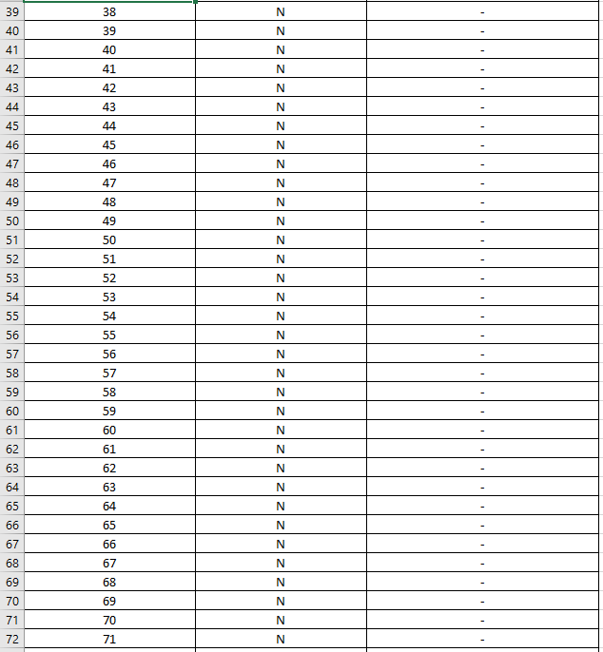
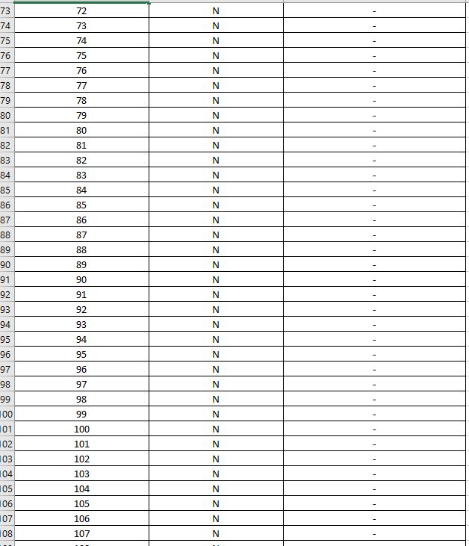

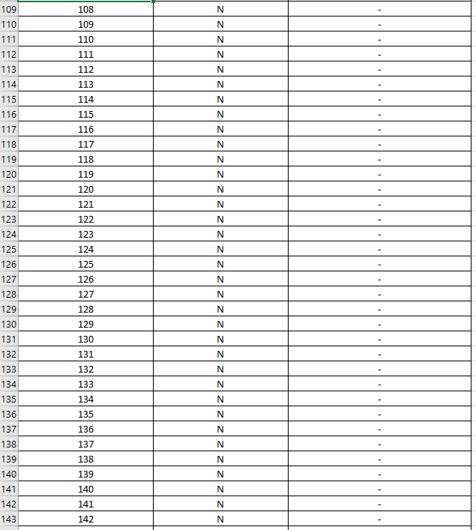

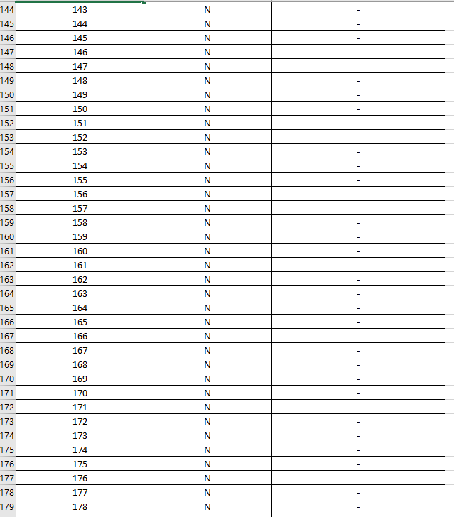

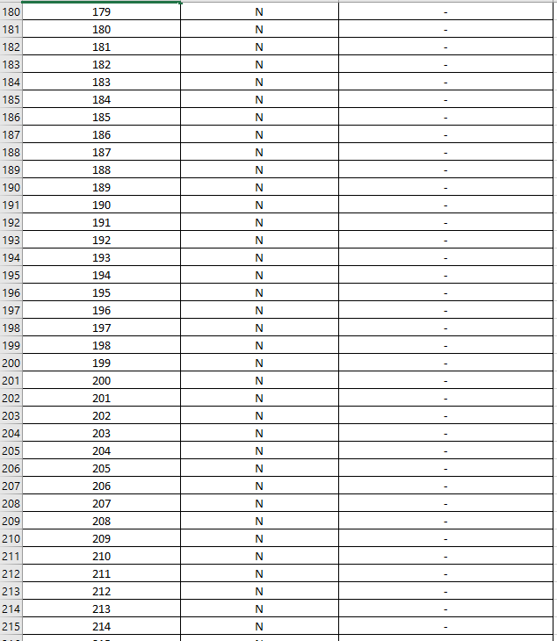

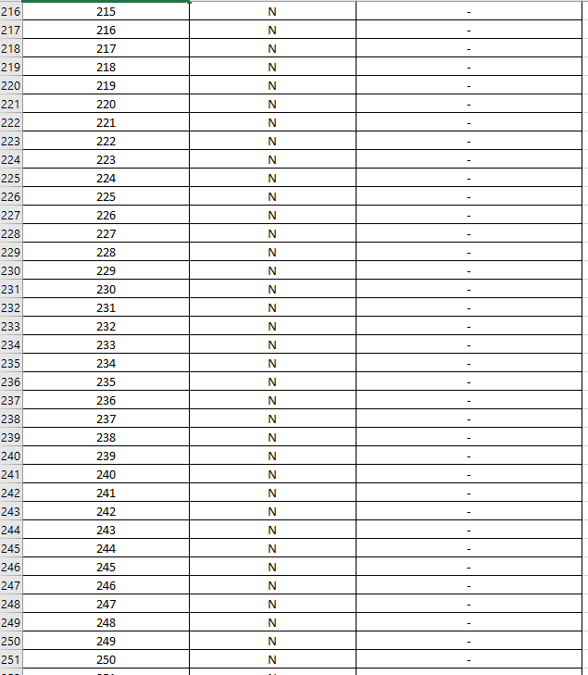
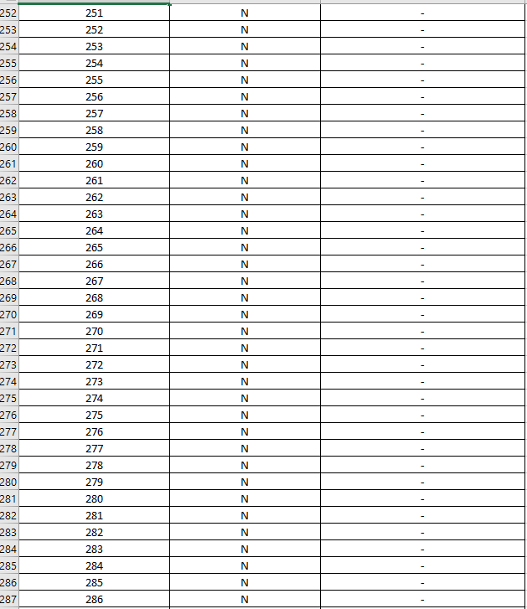
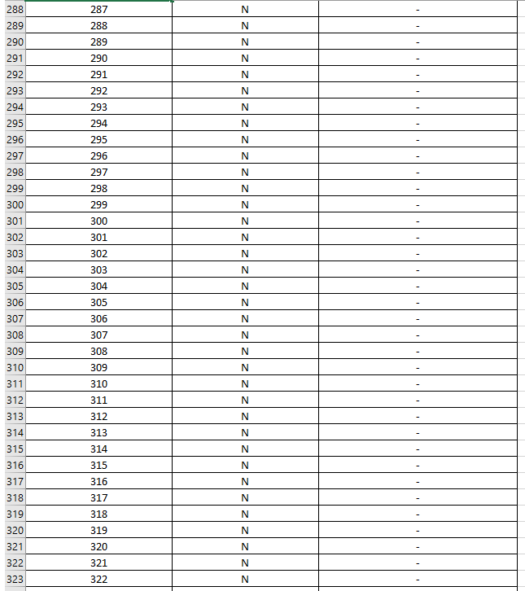
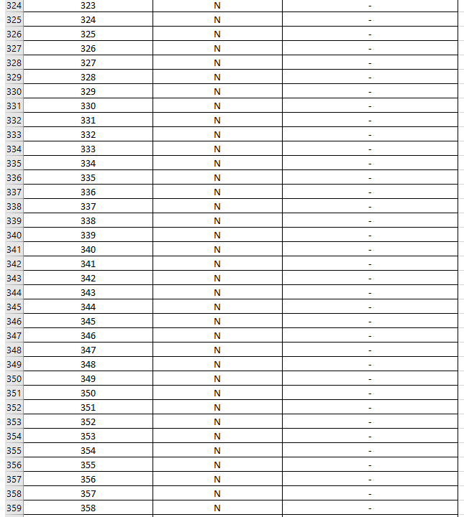
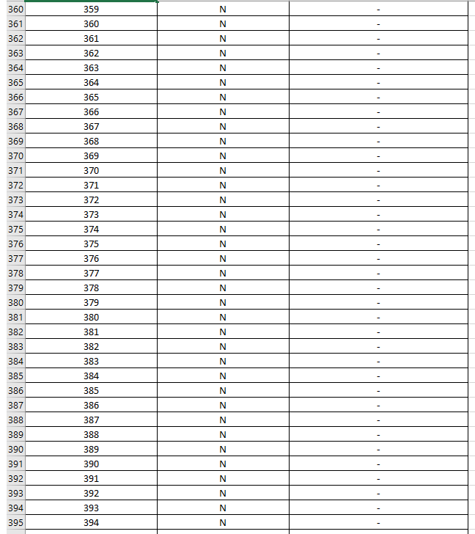
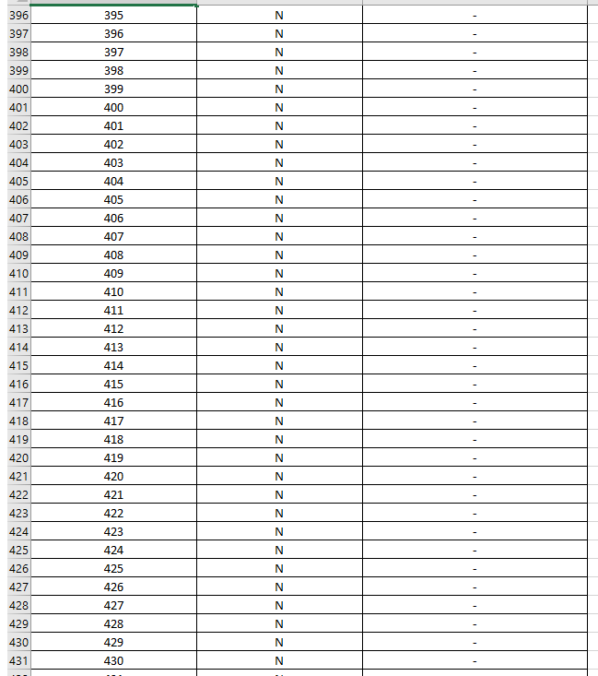
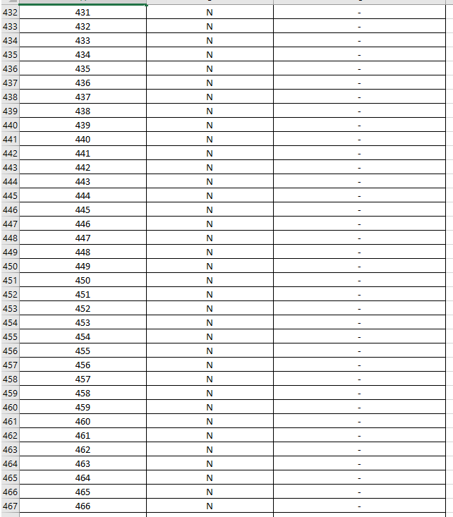
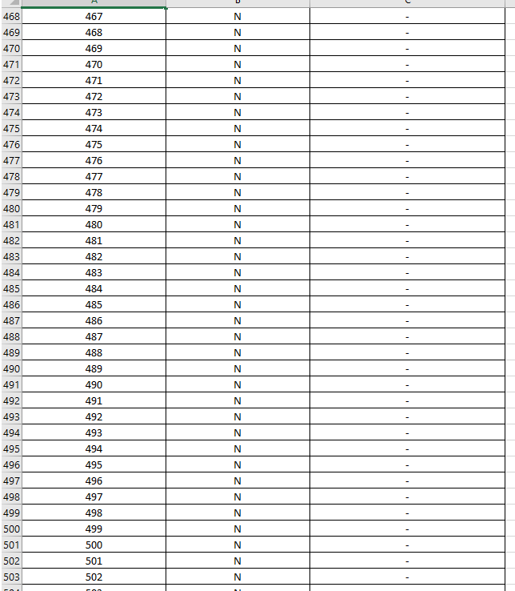
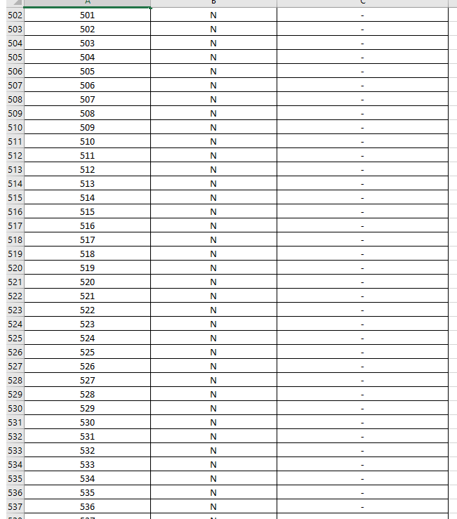
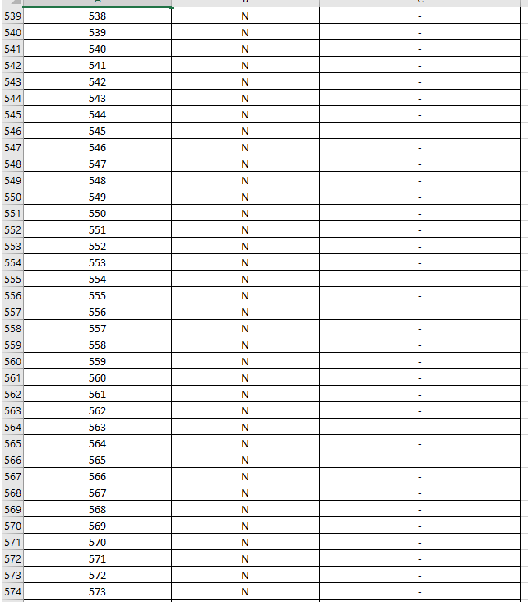
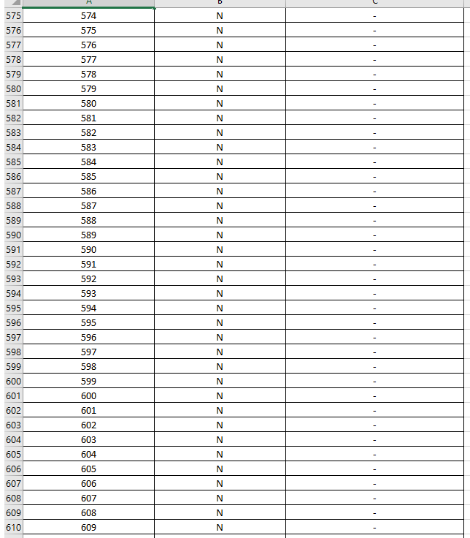
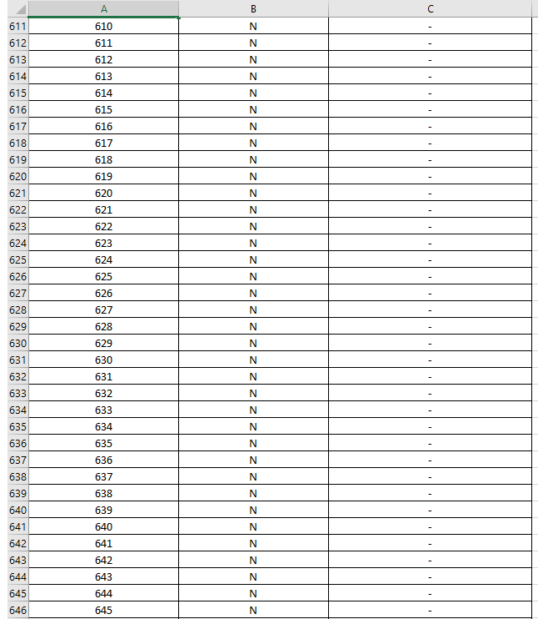
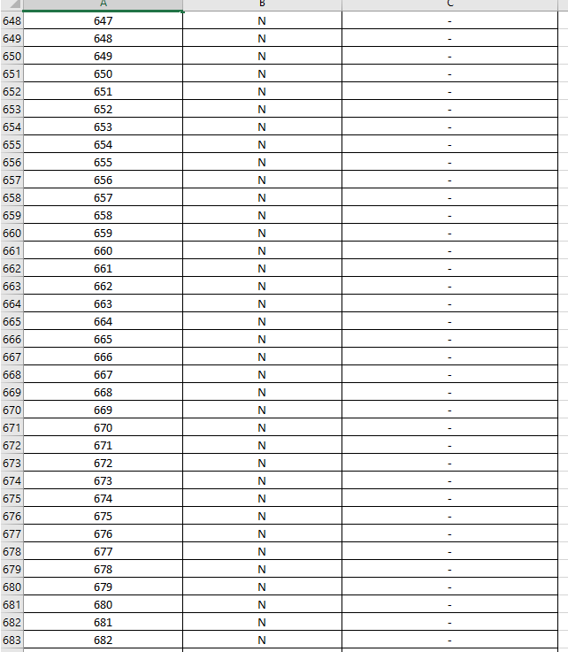
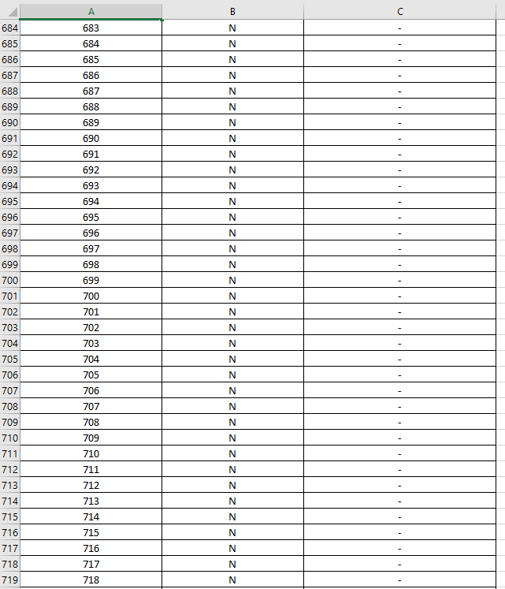
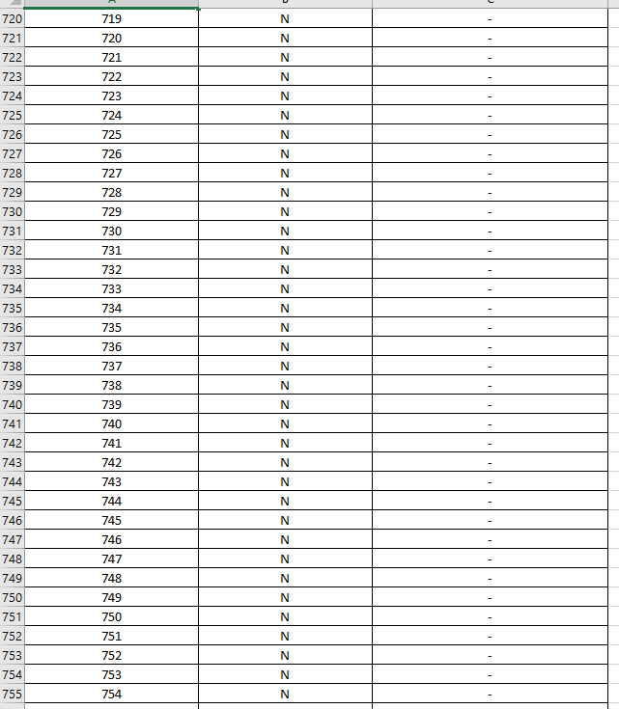
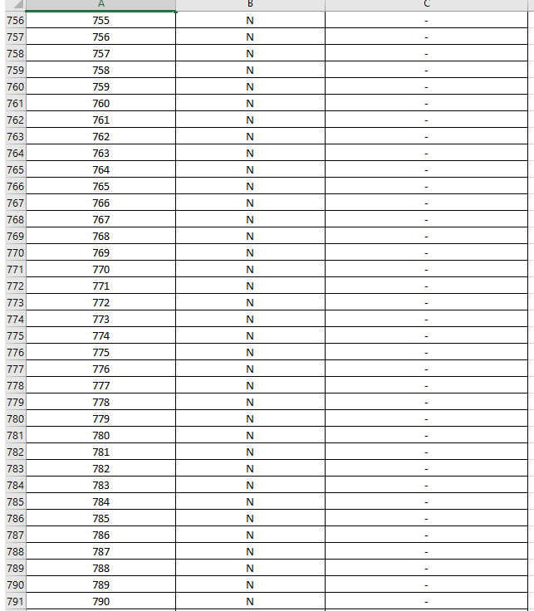
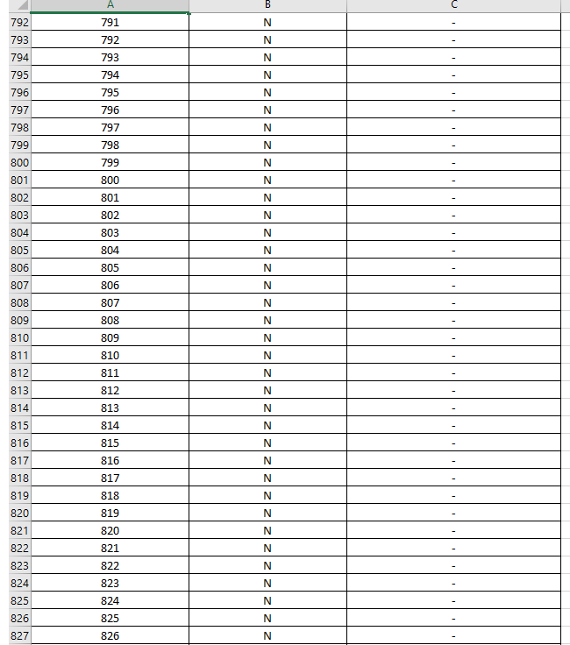
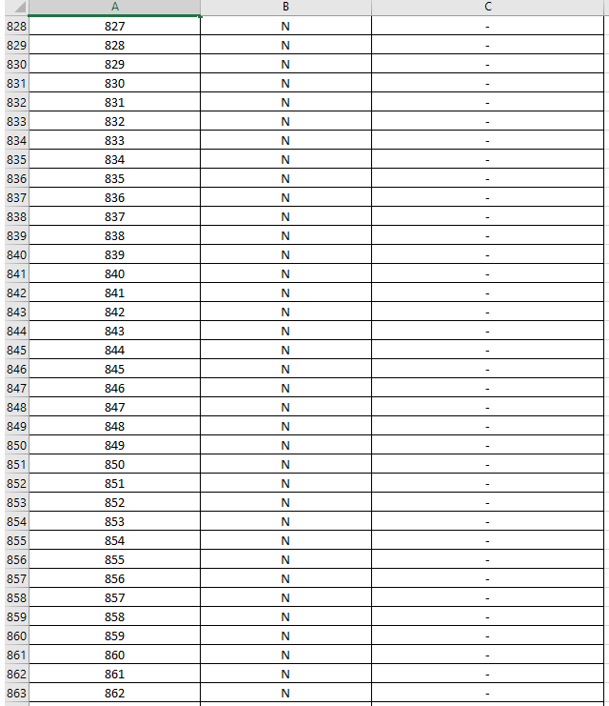
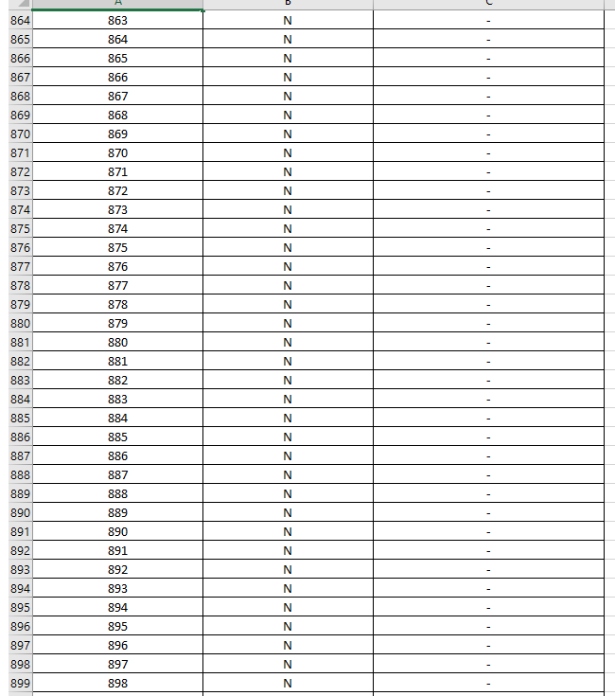
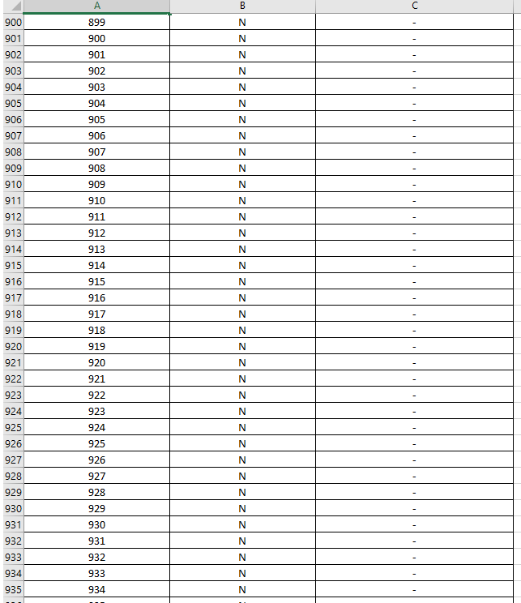
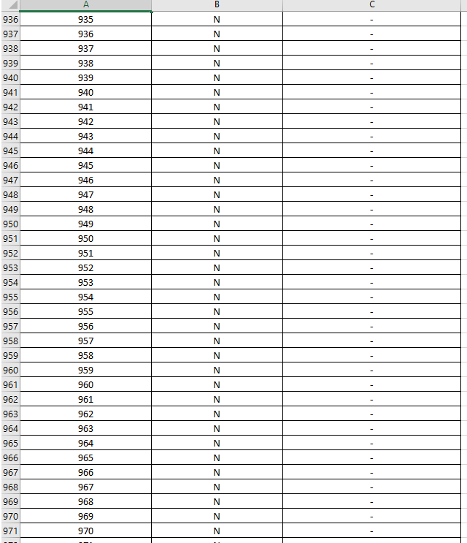
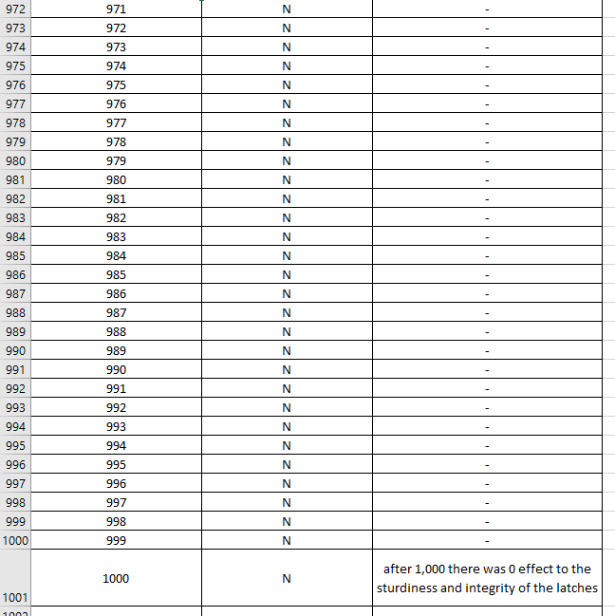

Table 3.
Testing Data for Hinge Test

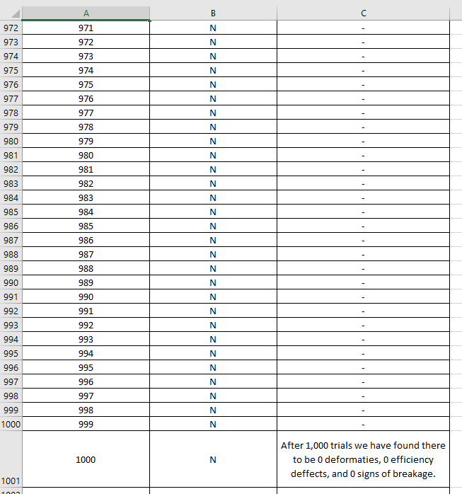

Table 4.
Testing Data for Handle Test
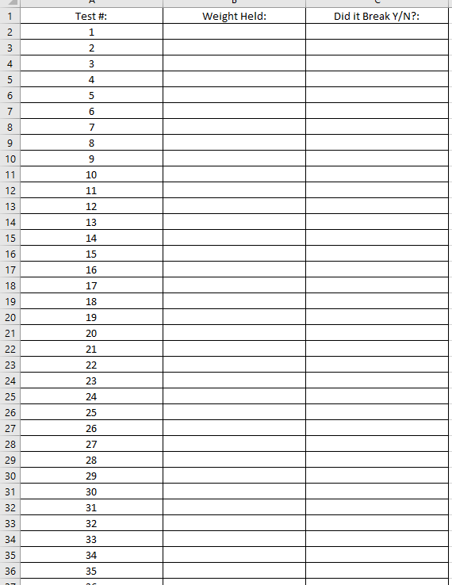

5.0 Conclusion
5.1 Redesign:

The results conclude that this is a very sturdy and well-built prototype/model. It also proves that the model was build using different materials due to money constraints, making it heavier than wanted. In order for the briefcase to work efficiently, the core of the design must be constructed of something much lighter. This would improve the efficiency of the briefcase and it would improve the productivity of the consumer.

Table 5.
Expense Report for Model
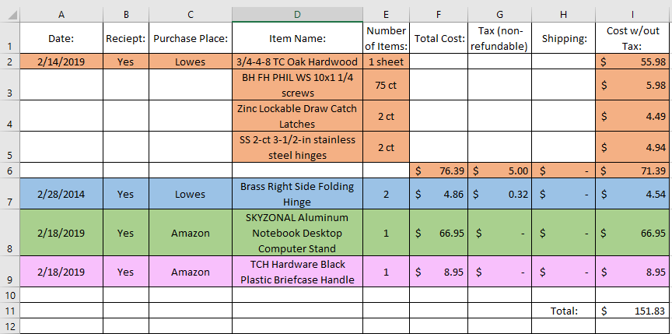

5.2 Concluding Remarks:
After the completion of this project we have concluded that our model is effective but could be way better. Our results show that the population realizes there is a problem and we feel that we solved that problem. It is clear that we did our job by completing the research, the surveys, the design, the model, and the evaluation. But in all reality this product would not make it in any market. We would need to make something so new that nobody has seen and then advertise it like crazy in order to have a successful product. As of now we just have a wood box with a computer stand, handle, latches, and hinges on it. It was an experience and something that sets us up for future jobs in entrepreneurship. So, from this class we have gained experience as a businessman rather than an engineer. We learned that we if we were to re-construct this model, we would have made the thicknesses different, we would have used thinner material, etc.

6.0 Recommendations
6.1 Further Studies:

There were several unknowns which could affect the performance of the proposed solution. Further studies should be conducted in the following areas:
- Analysis of the wood from which the wood would warp or wear over time. This should be conducted because wood is a main component of the overall core of a briefcase. And in order for one to fully understand the full potential of this briefcase, a test would need to be conducted to prove this theory of how long before the board will wear/warp.
- Analysis of the computer stand to see how many times the computer stand can be lifted and closed before the joints start to break, deform, lack in performance, etc. We would know that the computer stand is compromised once the joints start to fall apart or the overall mechanisms no longer allow one to maneuver them anymore.
- Analysis of the overall integrity of the briefcase by conducting a test that will reveal how durable the briefcase is. This test would consist of the briefcase being dropped from a controlled height repeatedly. We would drop the briefcase to see how many times we could drop it before compromising it. We know it is compromised once we can visibly see into the briefcase. This is because once there is a visible hole that means there is room for water to enter.
- Analysis of the plastic briefcase handle to see how much weight it can withstand. This is important to the overall integrity of the design because if the handle breaks then the design is a fail. The last thing that one wants is to have their expensive materials stored in our briefcase and then the handle falls off because they stored too much. We will know that the plastic briefcase handle is compromised upon detachment from the body of the briefcase.
- Analysis of water consumption. This is critical because consumers will have expensive equipment contained in the briefcase, and if water enters, then those technological components might be ruined for good. We know the briefcase is compromised upon entry of any amount of water.
- Analysis of how long it takes for metal components to rust. This is important to calculate because if these metal components rust as soon as they are exposed to water and humidity then consumers will not want to purchase our product.
Table 6.
Test Criteria xlsx
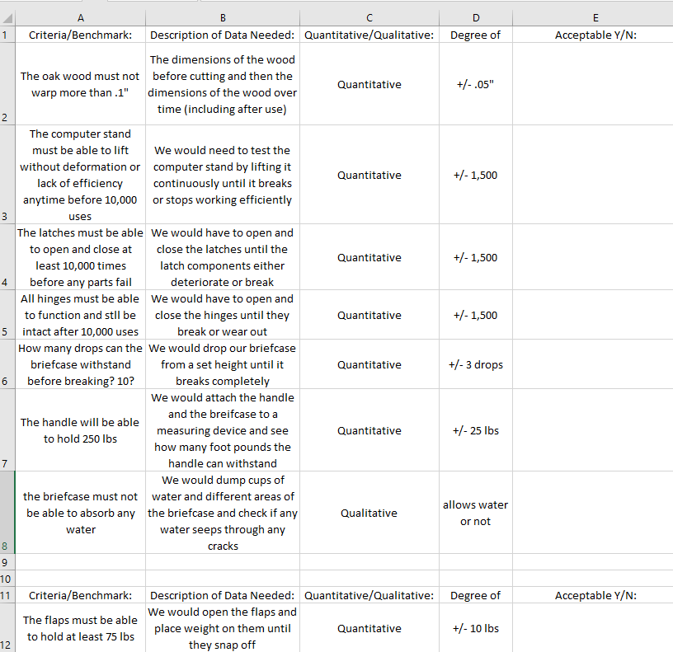
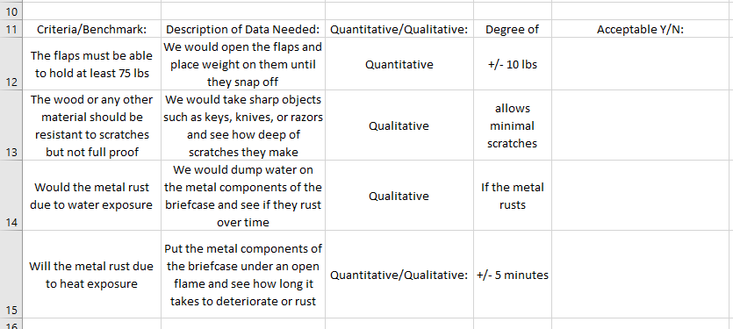

6.2 Suggested Actions:

One should take this information as a knowledgeable way to understand how working on the go a problem is and how our team was able to take this problem and create a solution. Whoever this may concern, should understand that all of this information is factual artifacts that have been created from brainstorming all the way to the final product. Everything in this technical report has been produced from a portion of the design process. If the reader takes anything from this report, it would be that the design process is extensive, rigorous, and often stressful & frustrating. But, in the end it teaches one how to follow steps, it teaches one to understand chain reactions, and it teaches one that you can’t start with a product and work backwards.

7.0 References
7.1 Works Cited:

Ariely, Dan, and Matt R. Trower. Payoff: the Hidden Logic That Shapes Our Motivations. TED Books/Simon & Schuster, 2016.
Burns, Poe Robert. “US2037919A - Sliding Writing Board for Desks.” Google Patents, Google, 3 Dec. 1935, patents.google.com/patent/US2037919A/en?oq=US2037919A%2B.
“declanedd7@Gmail.com.” Received by Anthony J Ruiz, and Cyndi A Ruiz, declanedd7@Gmail.com, 2018.
“Economy, Keynote Speech on the Future of Productivity: Productivity by All and for All.” Estadísticas - OECD, www.oecd.org/economy/keynote-productivity-by-all-and-for-all.htm.
Fried, Jason, director. Why Work Doesn't Happen at Work. TED: Ideas Worth Spreading, Oct. 2010, www.ted.com/talks/jason_fried_why_work_doesn_t_happen_at_work.
Grigsby, Nichols. “US2755156A - Portable Multi-Purpose Desk.” Google Patents, Google, 1954, patents.google.com/patent/US2755156A/en?oq=traveling%2Bdesk.
Halko, Monica E, and Karen Heitz. “US8919508B1 - Portable Suitcase Tabletop System.” Google Patents, Google, 2012, patents.google.com/patent/US8919508?oq=traveling%2Bdesk.
“How to Make the Most of Your Workday.” The New York Times, The New York Times, www.nytimes.com/guides/business/how-to-improve-your-productivity-at-work.
Lauren, et al. “Beyondblue.” On People in the LGBTI Community, 2013, www.beyondblue.org.au/get-support/online-forums/employment-and-workplaces/work-is-such-a-struggle.
Peck, Emily. “Proof That Working From Home Is Here To Stay: Even Yahoo Still Does It.” The Huffington Post, TheHuffingtonPost.com, 7 Dec. 2017, www.huffingtonpost.com/2015/03/18/the-future-is-happening-now-ok_n_6887998.html.
Ray, Sanjana. “Thinking Outside the Workspace: 50 Jobs That Don't Require Working in an Office.” YourStory.com, Yourstory, 15 Mar. 2017, yourstory.com/2017/03/thinking-outside-the-workspace/.
Shannon, John Gregory. “US9332835B2 - Portable Desk.” Google Patents, Google, 14 Aug. 2014, patents.google.com/patent/US9332835B2/en?oq=US9332835B2%2B.
Shyr, Michael H, and Godfrey S Shyr. “US5762170A - Combination Briefcase and Computer Bag Assembly.” Google Patents, Google, 1996, patents.google.com/patent/US5762170?oq=traveling%2Bdesk.
Technologies, Naveen Narayanan HCL. “The New Workplace Reality: Out of the Office.” Wired, Conde Nast, 7 Aug. 2015, www.wired.com/insights/2013/06/the-new-workplace-reality-out-of-the-office/.
Phillip, Raphal. “US2837394A - Portable Desk.” Google Patents, Google, 14 Mar. 1935, patents.google.com/patent/US2837394A/en?oq=US2837394A.

Zbikowski, Brett. “US7593222B2 - Laptop Computer Bag and Backpack Computer Bag with Extendable Table and Power Supply.” Google Patents, Google, 2006, patents.google.com/patent/US7593222?oq=traveling%2Bdesk.
李元补建李晓辉张朝坤谢万彬 . “CN205214715U - Mobile Office Equipment.” Google Patents, Google, 22 Oct. 2015, patents.google.com/patent/CN205214715U/en?oq=CN205214715U%2B.

Appendix A
Briefcase Complete Model IDW Sketch

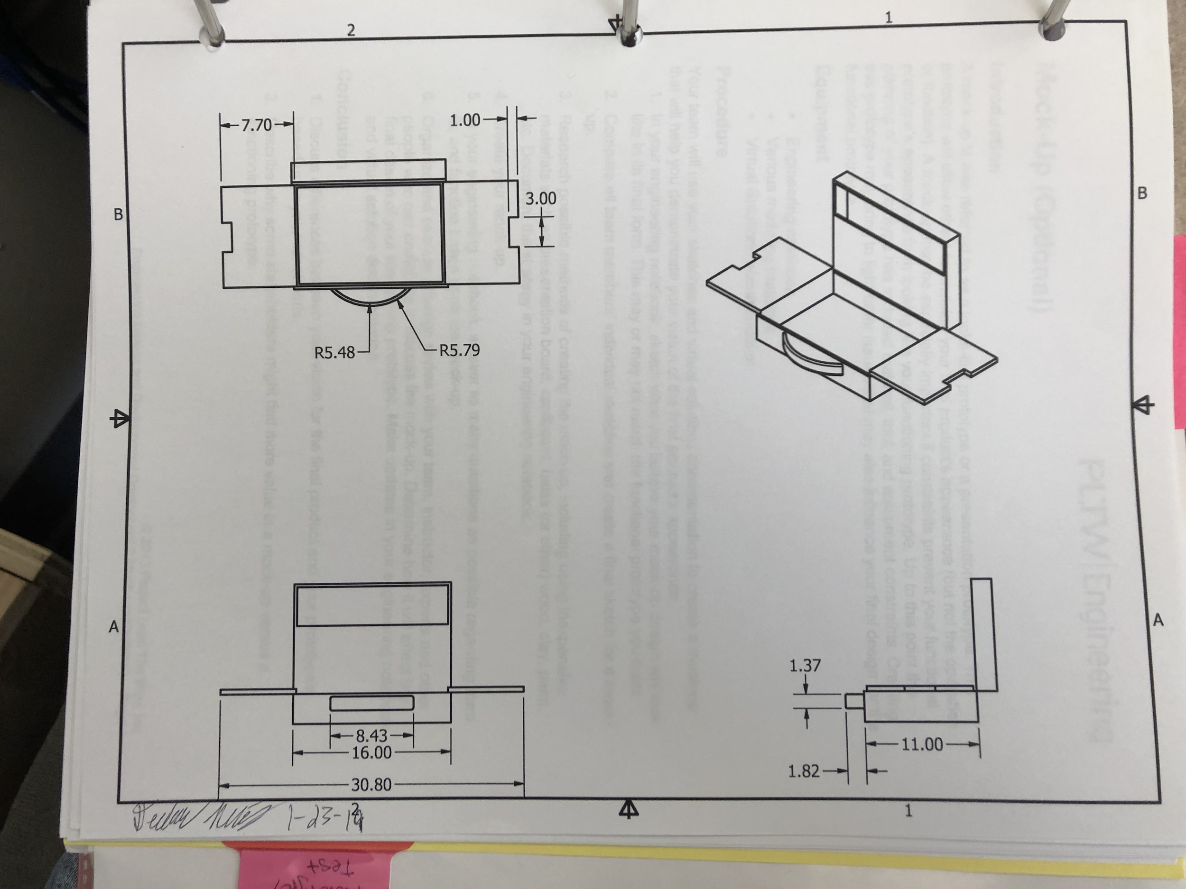

Appendix B
Portable Desk Patent
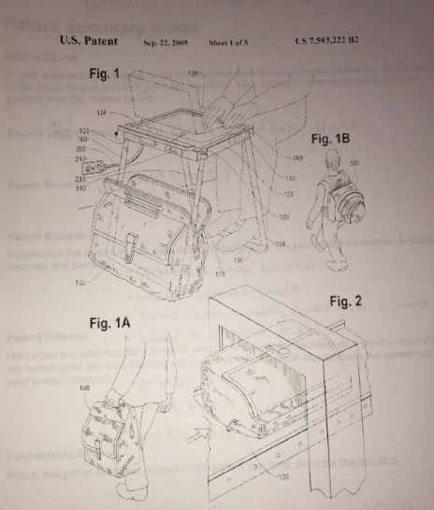

Appendix C
Suitcase with Flip-out Work Surface Patent
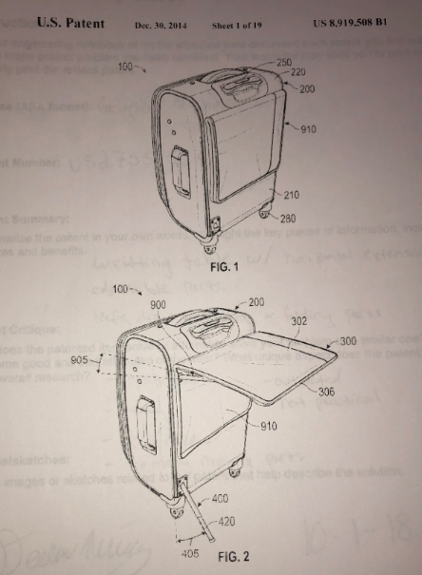

Appendix D
Heavy All Wood Traveling Desk Patent
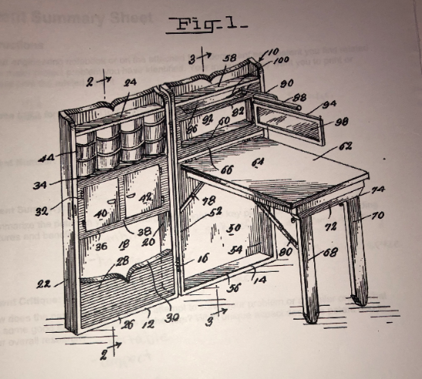

Appendix E
Rolling / Portable Filing Cabinet Patent
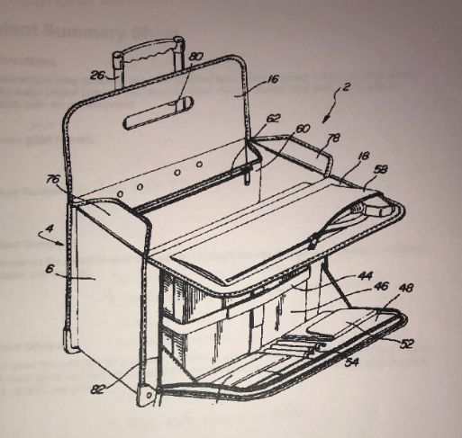

Appendix F
Suitcase Table Patent
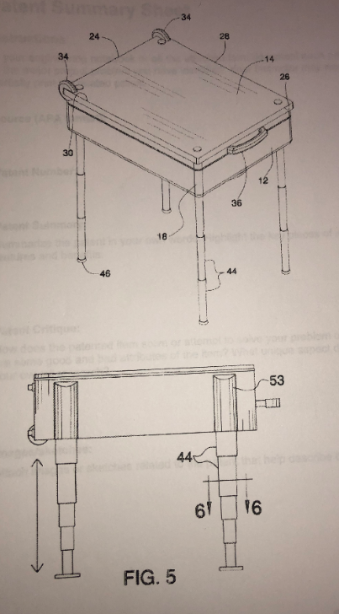

Appendix G
Rolling Organizational Working Suitcase Patent
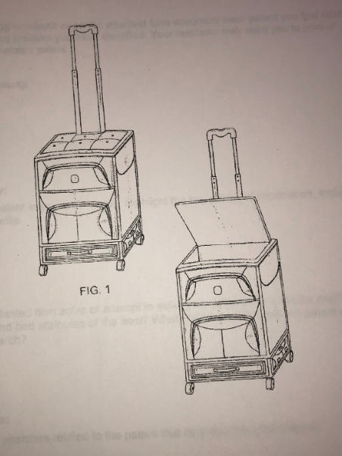

Appendix H
Businessman’s Suitcase Patent
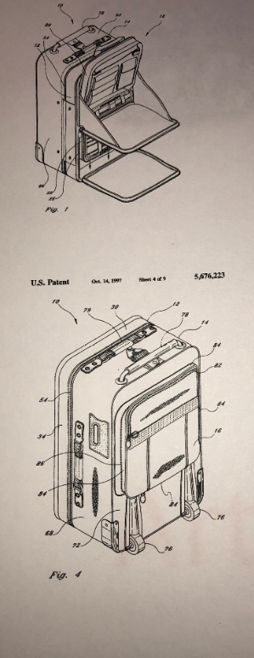
Appendix I
Similar Solution Matrix
